"It's okay – We're hunting Communists"  "It's okay – We're hunting Communists," October 31, 1947  Ink, graphite, and opaque white over graphite underdrawing on layered paper  Published in the Washington Post (18)  LC-USZ62-127327 | 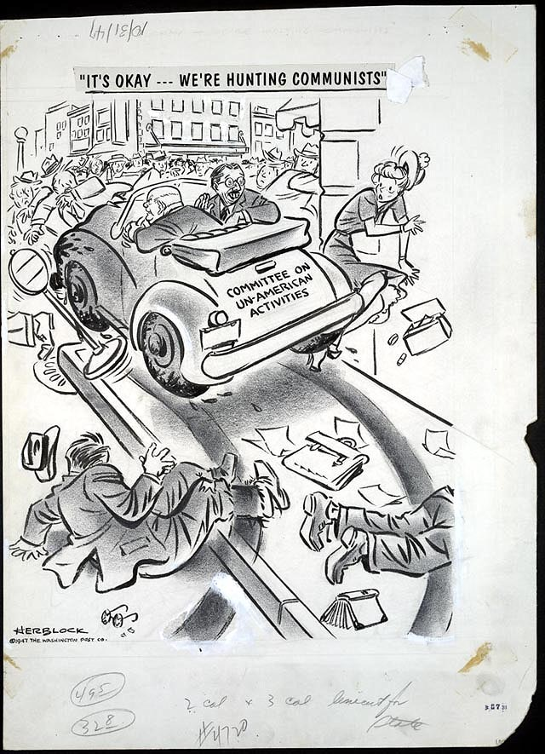
"Fire!"  "Fire!" June 17, 1949  Reproduction from original drawing  Published in the Washington Post (25) | 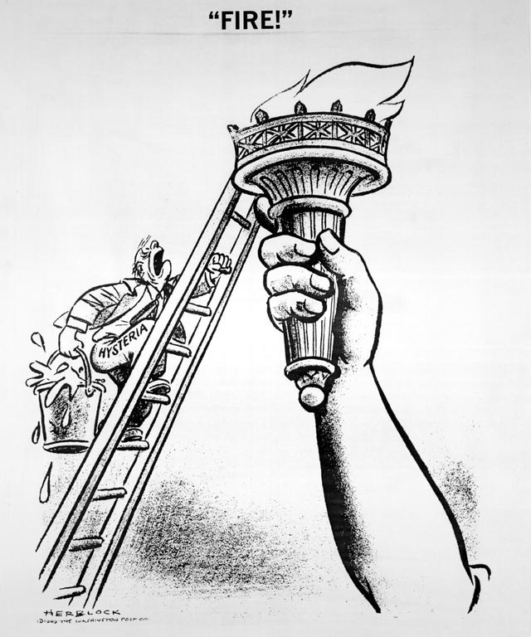

"You read books, eh?"  "You read books, eh?" April 24, 1949  Ink, graphite, and opaque white over graphite underdrawing on layered paper  Published in the Washington Post (24)  LC-USZ62-127202 | 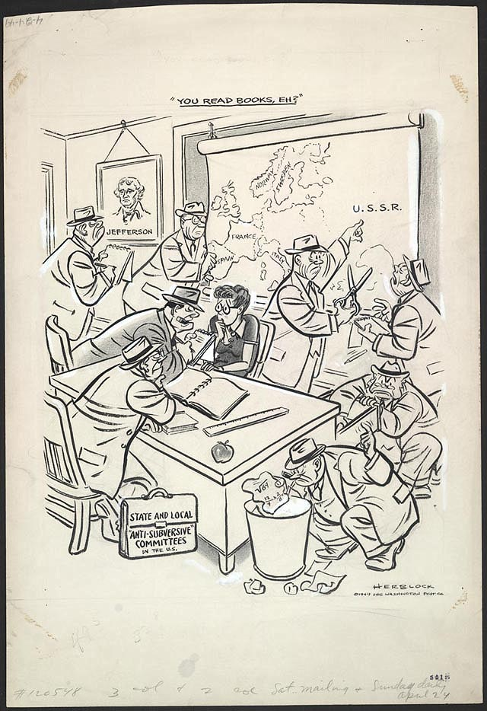
"You mean I'm supposed to stand on that?"  "You mean I'm supposed to stand on that?" March 29, 1950  Reproduction from original drawing  Published in the Washington Post (27) | 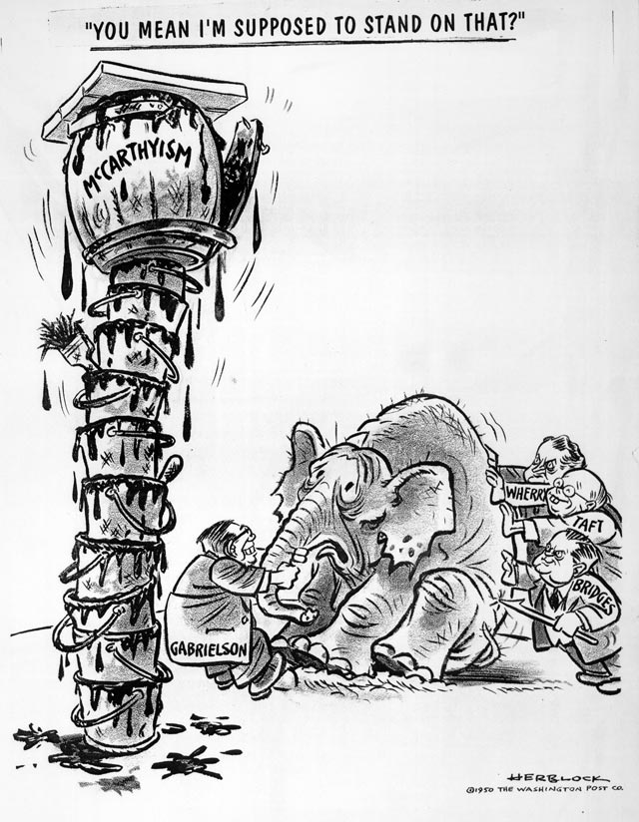

"We now have new and important evidence"  "We now have new and important evidence," May 8, 1950  Ink, graphite, and opaque white over graphite underdrawing on layered paper  Published in the Washington Post (28)  LC-USZ62-126908 |  | 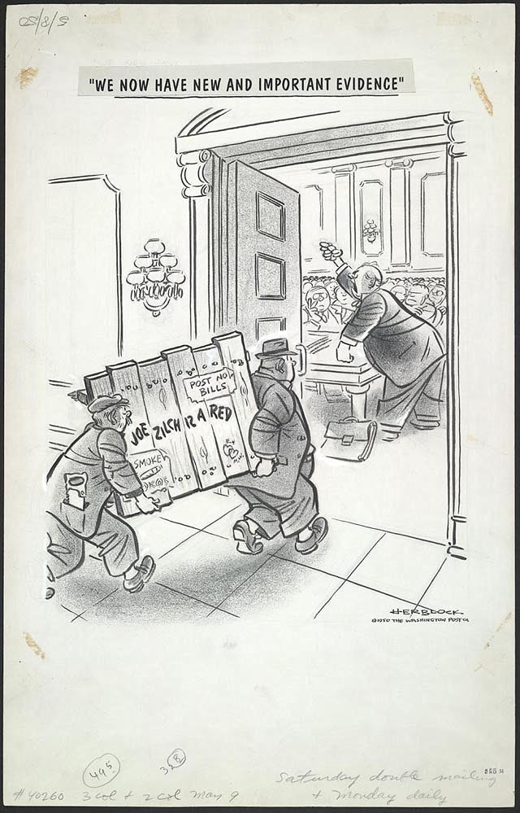
"Say, what ever happened to 'freedom-from-fear'?"  "Say, what ever happened to 'freedom-from-fear'?" August 13, 1951  Reproduction from original drawing  Published in the Washington Post (31) | 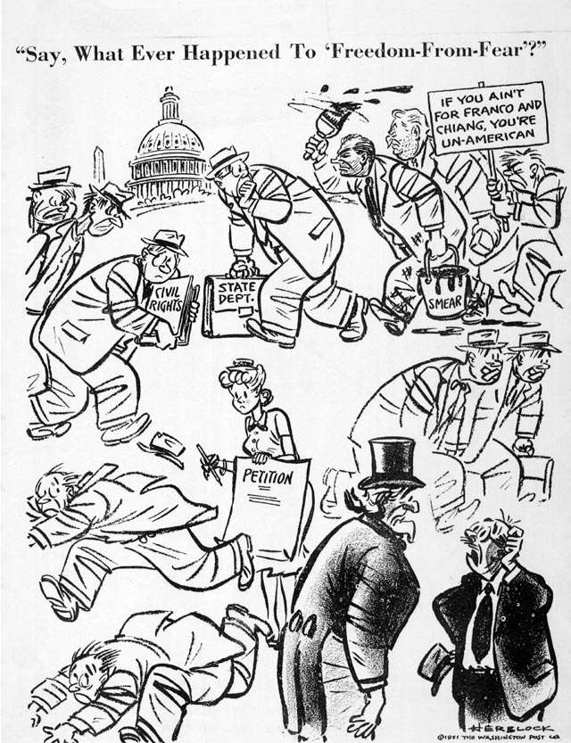
Nothing exceeds like excess  Nothing exceeds like excess, September 12, 1952  Ink, graphite, and opaque white over graphite underdrawing on layered paper  Published in the Washington Post (32)  LC-USZ62-126909 | 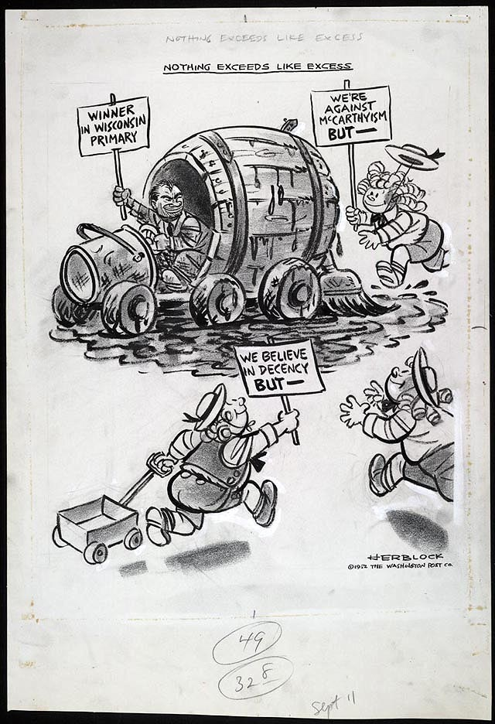
"Have a care, sir"  "Have a care, sir," March 4, 1954  Reproduction from original drawing  Published in the Washington Post (33) | 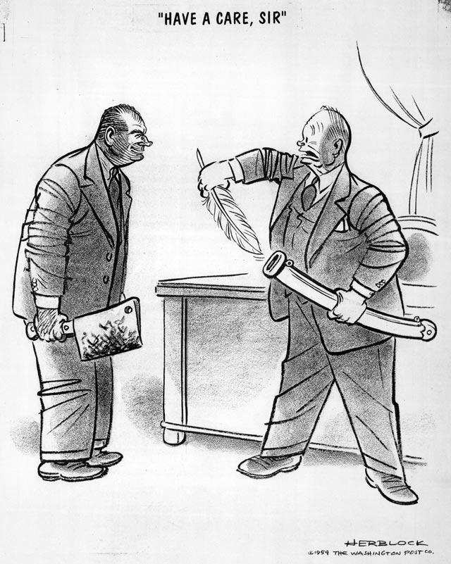
"I have here in my hand . . ."  "I have here in my hand . . .," May 7, 1954  Ink, graphite, opaque white, and overlay over graphite underdrawing on layered paper  Published in the Washington Post (34)  LC-USZ62-126910 | 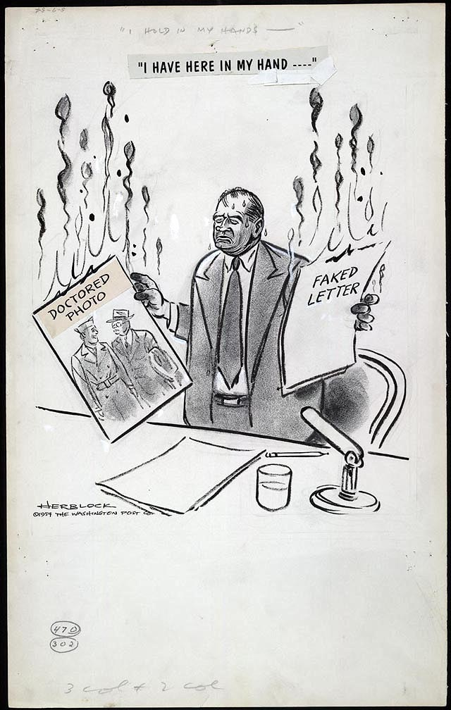
"Stand fast, men -- They're armed with marshmallows"  "Stand fast, men--They're armed with marshmallows," August 11, 1954  Reproduction from original drawing  Published in the Washington Post (35) | 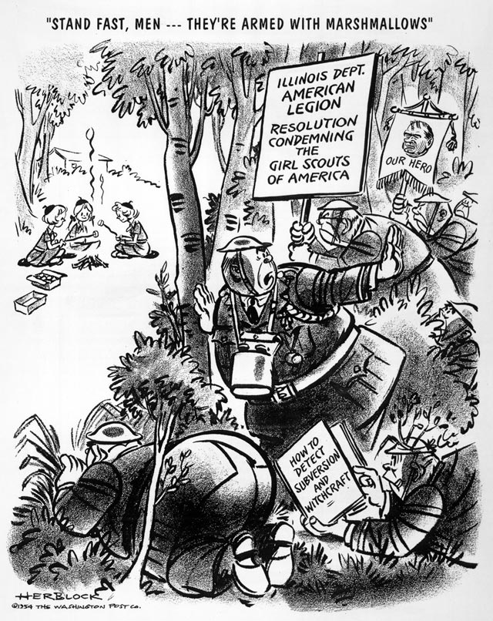

"Here he comes now"  "Here he comes now," October 29, 1954  Reproduction from original drawing  Published in the Washington Post (36) | 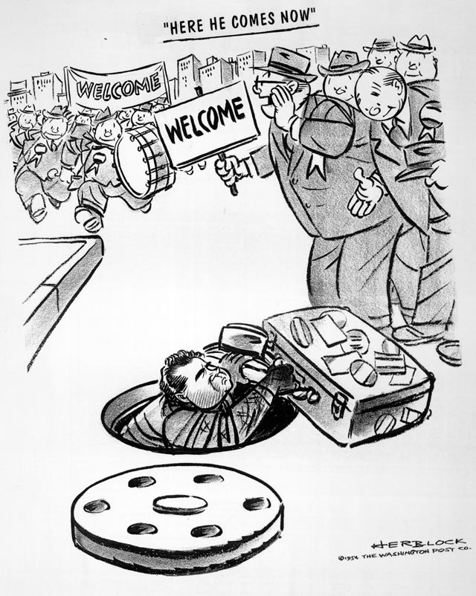
"On this order for a new typewriter  ribbon -- did you know you forgot to  stamp ‘Secret'?"  "On this order for a new typewriter ribbon--did you know you forgot to stamp ‘Secret'?" July 25, 1956 Ink, graphite, and opaque white over graphite underdrawing on layered paper  Published in the Washington Post (40)  LC-USZ62-126911 | 

