Fishing with Hemingway
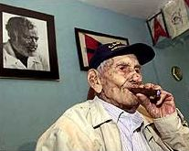
Gregorio Fuentes, who was boat captain to Ernest Hemingway when the late American writer lived in Cuba, died early Sunday, January 13. He was 104 years old. For nearly 30 years, Fuentes was captain, cook and friend to the American writer. Many believe he was the inspiration for Santiago, the protagonist in Hemingway's classic short novel The Old Man and the Sea, which is widely regarded as one of the greatest literary works of the twentieth century.
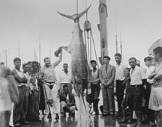
Hemingway met Fuentes in 1928, and in the 1930s hired him for $ 250.00 a month to care for his boat, El Pilar. Fuentes later inherited El Pilar and donated it to the Cuban government, which displays it outside Hemingway's former home, now a museum on the outskirts of Havana.
In this week's online lesson you will explore the life and works of Ernest Hemingway.

Picturing Hemingway
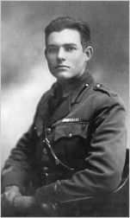
For this week's first site travel to the Smithsonian's National Portrait Gallery and visit the online exhibition Picturing Hemingway: A Writer in His Time. Click any of the three pictures to begin the tour. First you see a famous quote of Hemingway's that articulates his lean style. Click the quote to continue on. At this point you will see the main navigation along the top of the page with links to each section. Read each page and then click Begin Tour or Next to continue. Answer the following questions as you complete each section.
Beginnings. What did Hemingway learn to do at Walloon Lake in Michigan? How did this influence his life and his writing? Was Hemingway a good student in High School? What was his first job after graduating? How was he injured in 1918?
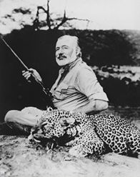
Paris Years. Who was Hemingway's first wife? Who was Gertrude Stein and what did Hemingway learn from her? Who was Ezra Pound and how did he influence Hemingway? Who was F. Scott Fitzgerald and what did he have to say about Hemingway? What is the name and setting of Hemingway's first novel?
Middle Years. What is the subject of the novel For Whom the Bell Tolls? Hemingway's African safari inspired which novel and short stories? What sport did Hemingway enjoy in Key West, Florida?
Later Years. In what magazine was The Old Man and the Sea originally published? What indirect role did Adriana Ivancich play in its writing? Why did Hemingway shave his head during his 1953 safari? What prizes did Hemingway win in 1953 and 1954? How did Hemingway's life end?

Michael Palin's Hemingway Adventure
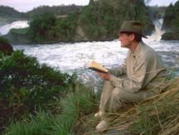
British comedian Michael Palin retraced the life of Ernest Hemingway in a television series for the BBC, rebroadcast on PBS. Visit the web site of Michael Palin's Hemingway Adventurefor a wealth of great information about the series and the writer. Stops along the way include Chicago and Michigan, Italy, Paris, Spain, Africa, Key West, Cuba, and the American West.
Visit each section; use the Next link at the bottom of each page to progress through it. As you read, look for photos or links to video clips from the television program.

New York Times Featured Author
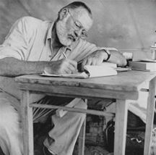
The third and final web site in this lesson, The New York Times Online, focuses on the extraordinary writings of Ernest Hemingway rather than his adventurous life. Begin by reading Hemingway in Our Times, an introductory essay by biographer Mike Reynolds. How would you summarize the influence of Hemingway's writing on American literature? Which novel received the most favorable reviews overall? What did Hemingway have to say about New York critics?
Return to the main page and read the archive ofInterviews and Critical Essays published in the Times. And if you didn't before, listen to the recording of Hemingway's Nobel Prize Acceptance Speech.

Newspaper Activities
Hemingway wrote great works of fiction based on his life experiences. How might the life experiences of someone today translate into great fiction? In a current issue of The Cincinnati Enquirer, choose an article about someone whose profession or experience interests you. From the news article, develop a rough outline for a novel--a story based on the experiences of the person you selected. What would be a good title for the story? If you can, write a few pages of the story or a whole chapter.

